v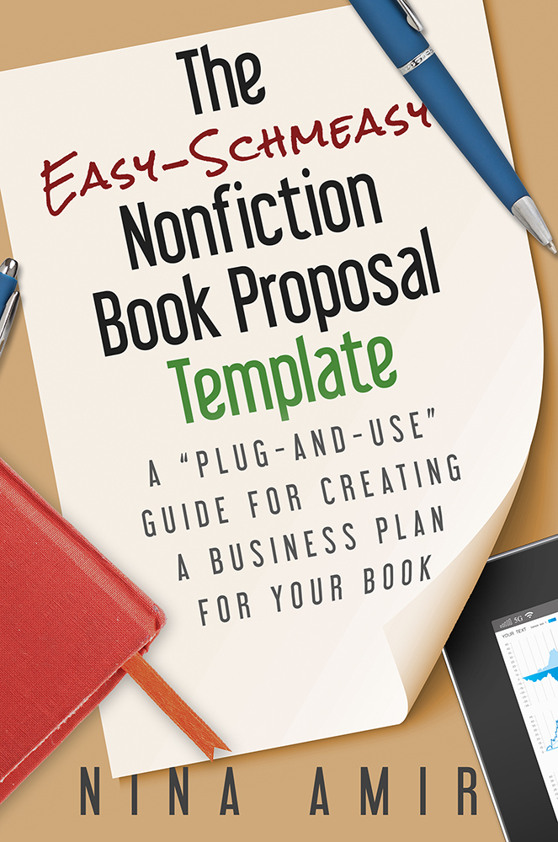

A Proposal for:

[Title]
[Subtitle]

By [Your Name]
[Title, Degree, Position/Employer]

Optional:
Forward by [Name}
First in a series of [#] of books

Name
Street Address
City, State, Zip Code
Phone Number(s)
Website Address and/or Blog
Email address
Social Media Addresses

Table of Contents

Overview page #
Markets page #
About the Author page #
Author’s Platform page #
Mission Statement page #
Spin-offs page #
Promotion page #
Competing Books page #
Complementary Books page #
The Outline page #
List of Chapters page #
Chapter Summaries page #
Foreword page #
Sample Chapters page #
Chapter X page #
Chapter XX page #

Title of Book
Subtitle

Lead/Anecdote/Introductory information that catches someone’s attention. (1-3 paragraphs).
Pitch including title, subtitle, in less than 50 words (title isn’t included in word count). Sentence including number of estimated or actual length of your book including details such as illustrations and back matter (consisting of glossary, bibliography, etc.).
Summary of book in 1-3 paragraphs. You might include other books or authors upon which you have modeled your project.
Benefits – sentence lead in and bulleted list.
Features – sentence or two lead in and bulleted list or explanation. (optional)
Information on a self-published edition. (optional)
When you can deliver the manuscript: The author can deliver the manuscript in ___ months.

Markets

[Title of book] will be aimed at the _________ and ________ markets. It will be placed in the _________ category.

The _________________ Market

Describe market. If it has segments, break these down with bullets.

The _____________________ Market

Describe market. If it has segments, break these down with bullets.

About the Author

One-page bio written in third person. Include a professionally taken photo at the top. Start with the most important information and work down from there. Include testimonials, credentials, expertise, and relevant links.

Mission Statement

One paragraph explaining why you must write this book.

Author’s Platform

Presentations Scheduled for 2011-2012

• In discussions with [Organization’s Name] to speak Month year.

• Workshop Leader, “Title of Workshop,” [Organization Name], City, State, Month year.
• Teleseminar Presenter, “Title of Teleseminar,” 1 free introductory session and 5 paid sessions promoted through January podcast with [Organization’s Name], beginning in Month and running through Month 2011.
• Featured Speaker, “Name of Talk,” [Organization’s Name], City, State, Date Year.
- Presenter and Workshop Leader, “Title of Workshop” (3-day class), [Organization’s Name], City, State, Month Year.

Past Presentations

• Workshop Leader, “Workshop Title,” [Title of Conference], [Organization’s Name], City, State, Month Year.
• Featured Speaker, “Name of Talk,” [Organization’s Name], City, State, Month Year.
- Presenter and Workshop Leader, “Title of Workshop” (3-day class), [Organization’s Name], City, State, Month Year.

Television, Radio and Internet Radio/Podcast Appearances Scheduled for 2009-2010

• Regular Featured Guest, Radio Show Name, [Radio Station], City, State.

• Featured Guest, “Subject,” Radio Show Name, [Radio Station], City, State, Month

Year.

Television, Radio and Internet Radio/Podcast Appearances

• Regular Featured Guest, Show Title, Month Year.
• Featured Guest, “Subject,” “Title of Show” with host, website , Month Year.
• Guest Appearance, “Title of Show” with Host, website, Month Year

Print Interviews

• Expert Source, feature article on [subject], [publication], Date. link

Recently Published Articles

• “Title,” Publication, Month year. link

• “Title,” Publication, Month year. link

Awards

• x

Social Media

• unique visitors to website

• unique visitors to blog

• number of likes on FB page

- number of friends on FB profile

• number of tweeple on Twitter

• number of connections on LinkedIn

• number of people on mailing list

Additional Platform Elements

• member of organization(s)

• etc.

Spin-offs

The author will follow this book with _ more books on topics touched on or related to [the title of your book].
• X
• X
• X

Promotion

Pre-Publication Promotion Plan

The author will/has:
• joined www.ExpertClick.com. Please ask me about this—great for nonfiction writers. (Save $100 with this link: www.ExpertClick.com/discount/Nina_Amir)
- Set up…
- Created…
Post-Publication Promotion Plan

The author will:
• purchase a three-to-six month advertisement with Radio-TV Interview Report and/or Best Guest Digest to generate television and radio interviews related to [title of your book].
• employ the services of a publicist or PR agency, such as Annie Jennings PR or Planned Television Arts, to help her obtain television and radio interviews.
• use the services of PRWeb.com during the first three months after the book’s release to blast out several press releases about [title of book].
• set up a publicity tour in the following major markets:
- New York City
- X
- X
• send press kits to local media in the cities where she is scheduled to speak or hire a publicity firm to do so for her.
- The author will give a minimum of talks per year in locations around the country and per year locally.
• pursue speaking engagements by sending out letters and/or speaker’s kits weekly.
• sell a minimum of books per year by offering them at all her lectures, talks, seminars, and workshops as well as on her web site.
• a virtual book tour.
• blast out information using social networking already set in place on Facebook, Twitter, and LinkedIn.
• offer columns, essays and articles to e-zines and print publications in exchange for a promotional bio.
• contact the following opinion-makers for book endorsements:
1. x
2. x
3. x

The author’s promotional and publicity efforts will be coordinated with those of the publisher.

Competing Books

The following two books are closest in subject matter and, therefore, represent the most direct competition to [Title of book]:
1. Title, Subtitle, by Author (Publisher, copyright year, # pages, paperback or hardcover, $ price). Two incomplete sentences joined by a semicolon; first one says what is positive about the book and the second one says what is negative about the book.
Conclude with a paragraph comparing these books to your book or you as an author to these authors or both.

Complementary Books

Readers purchasing the following titles might also purchase [title of your book]:

1. Title, Subtitle, by Author (Publisher, copyright year, # pages, paperback or hardcover, $price).
2. Title, Subtitle, by Author (Publisher, copyright year, # pages, paperback or hardcover, $price).
3. Title, Subtitle, by Author (Publisher, copyright year, # pages, paperback or hardcover, $price).
4. Title, Subtitle, by Author (Publisher, copyright year, # pages, paperback or hardcover, $price).
5. Title, Subtitle, by Author (Publisher, copyright year, # pages, paperback or hardcover, $price).
Include a paragraph that compares your book to these books or you as an author to these authors.
List of Chapters

Introduction page #
Chapter 1 page #
Chapter 2 page #
Chapter 3 page #
Chapter 4 page #
Chapter 5 page #
Chapter 6 page #
Chapter 7 page #
Chapter 8 page #

Chapter 9 page #
Chapter 10 page #

Chapter Summaries
Introduction 4 pages

Each chapter is summarized in the future tense (This chapter will…). Try to use active verbs, avoid saying “this chapter” too often. Be creative, and highlight the most important aspects of the chapter.

Chapter 1 – Title 10 pages

The trend these days is to keep summaries short—a paragraph, two at most.

Sample Chapters

Pick your best two or three chapters—the ones that highlight the book's benefits or unique features and information. You need to include about 25-30 pages of manuscript.
Also include your foreword, if you have one.

